19.17: The work done is positive from a to b and negative from b to a; the net work is the area enclosed and is positive around the clockwise path. For the closed path 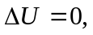so 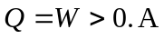 positive value for Q means heat is absorbed.
b)
c) For the counterclockwise path, Q = W < 0. W=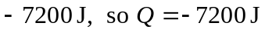and heat is liberated, with |Q|=7200 J.

